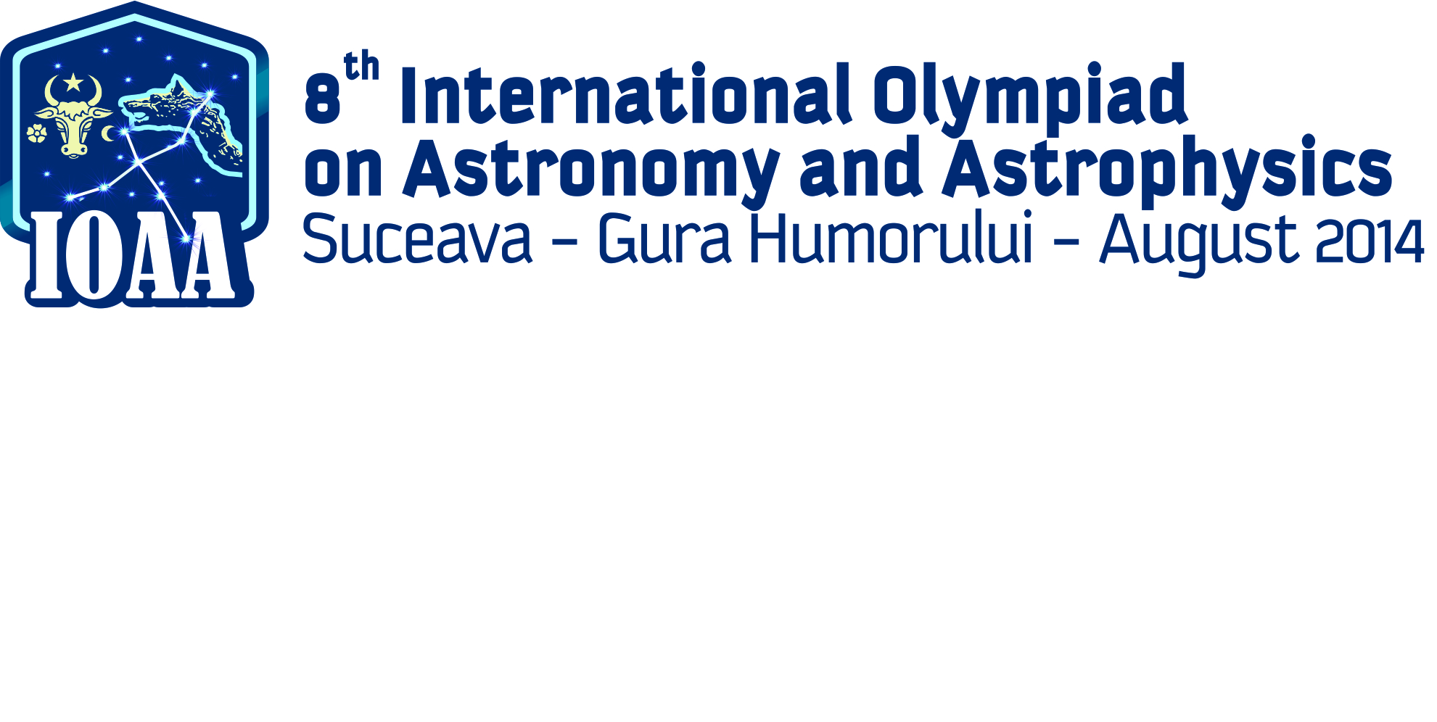

**TEAM COMPETITION**

For this test you have to use the materials you found in the box: milimetric paper, plasticine, a ruler, wire, knife, scissors, auto adhesive paper, adhesive band, pins and a support plate.

**Defensing the Earth with plasticine, a wire, a pen and scissors**

A giant asteroid, potentially dangerous for Earth flight towards the Earth. The collision is inevitable so from an artificial Earth’s satellite a nuclear missile will be launched in order to brake into parts the asteroid. You are in a control post, with no computers, only with materials from the box you receive. In one hour and half you have to send the box with the solution of the following problems in order to plan the defensive strategy for our planet.

**Real facts**

**The asteroid 2013 UX11 (Galați – Romania 2013)**

During the night between 29th and 30th of October 2013, two astronomers Ovidiu Tercu and Alex Dumitriu from the Astronomic Observatory from Galati, Romania discovered an asteroid in the Torro constellation. The asteroid named 2013 UX11 has a diameter of  . This was the first time that an asteroid was discovered by Romanian astronomer in order to make this problem for IOAA. After analyzing the data in the “Minor Planet Center” the following communication was received: ***2013 UX11*** is an asteroid from the Main Belt of Asteroids, orbiting between the orbits of Mars an Jupiter with period  with an eccentricity *e* = 0,15.

a) *Find out* the characteristics of orbit of the ***2013*** UX11 regrdless to the Sun- . You know the mass of the Sun and the gravitational constant 

b) *Find out the maximum and respectively* the minimum of the temperatures of the surface of the asteroid. You know : Temperature of the surface of the Sun  the radius of the Sun  the albedo of the surface of the asteroid 

**The plan**

You have received a scaled sketch of the positions of the Earth (P), satellite (S) and the point where the missile have to hit the asteroid. The distance between asteroid and the Earth is .

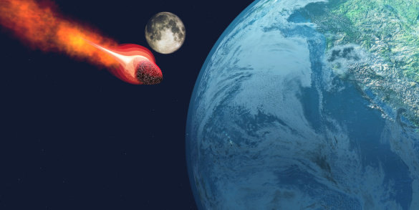

You have to analyze the problem of saving the Earth only by using the materials from the box in the following conditions:

**A. For a given speed of the missile** , **the problem have only one solution i.e. there is only one trajectory form S to A, available for the missile in order to hit the asteroid.** You have to determine by using the materials :

a) the elements of the missile trajectory;

b) the direction of the initial speed of the missile  in order to be able to hit the asteroid. Indicate on the paper sheet the angle you measured.

c) Calculate the launch velocity of the missile  if you know the mass of the Earth  and the gravitational constant 

d) Using the plasticine imagine a very simple device in order to calculate the duration of missile flight from launch untill the impact with the asteroid.

e) Using the wire, measure the distance covered by the missile from the launch-point to the impact-point.







A



**B. Two solutions .** To be sure that the asteroid will be destroyed from another satellite orbiting the Earth at another altitude will be launched in the same moment of time, a second missile in order to hit the asteroid simultaneously with the first missile. Notations P – center of the Earth; S – launch position of the new missile, A – the impact point at distance  from the Earth.

In this configuration you know that there are two possible trajectories, form **S** to **A** for the second missile. For that a mysterious point X is marked on the sketch.

You have to *find out*:

a) the elements of the two possible trajectories.

b) For each trajectory determine the directions of the launch-speeds, at the same velocity which allows the missile to hit the target;

c) The launch- velocity  if you know the maa of the Earth  and the gravitational constant 

d) Using the plasticine imagine a very simple device in order to calculate the durations of missile flight from launch till the impact with the asteroid for the both trajectories

e) Using the wire, measure the distances covered by the missile from launch-point to the impact-point.









B



**C. Security zone**

You have to delimitate around the Earth a security zone. From the point A of this problem you know that there is a unique possible trajectory for the defensive missile. This means that the pointA on the sketch is locate on a curve which delimitates a security yone for the Earth.

1. If you know that the triangle defined by the points **P-** the Earth, **S** – Sun, **A** – impact point remains unchanged in time establish the shape of the curve which delimitates the security zone
2. Draw on the paper this curve and determine its parameters
3. Where have to be situated the impact – point **A** in order to hit the asteroid simultaneously with to missiles
4. Use your plasticine device to fiind out the time spent by an fragment of the asteroid which flies after the impact with the missile, on the curve which delimitates the security zone

**Solving**

a)























 









b.



unde  este o constantă;





Densitatea fluxului energetic al Soarelui, la distanţa  faţă de acesta (acolo unde se află Asteroidul), însemnează energia tuturor radiaţiilor emise de Soare, care traversează unitatea de arie a unei suprafeţe, sub incidenţă normală, în unitatea de timp, adică:





Semisfera asteroidului expusă radiaţiilor solare este echivalentă cu un disc plan circular, având raza  şi aria suprafeţei  aşezat perpendicular pe direcţia Soare – Asteroid, astfel încât fluxul radiaţiilor solare incidente, *F*, la nivelul Asteroidului (adică energia solară incidentă le nivelul Asteroidului, în unitatea de timp), este:









În acord cu desenul din figura alăturată, ecuația bilanțului energetic al procesului analizat este:

Soarele

Asteroidul









**Fig.**







Stationary











Rezults













When the astheroid is at perihelium ;













When the astheroid is at aphelium.

**A.**

a)



































































** **

** **

**  **



























Din măsurători efectuate pe desen și din calcule, rezultă:

 

























b)

:













































c)





























:

– *K–K*;



+

*r*1 Apogee

*r*2, Perigee,:

*a =* (*r*1 + *r*2),

*a = *,

relație independent of α relationship for 







 









d)



 









The system has to be done







































According to the second Keppler law:







|  |  |  |  |
| --- | --- | --- | --- |
| *D* | *d* | *T* |  |
| 26 cm | 11 cm | 7,56 h | 3,19 h |

e) Measurements ao a wire along the elipse sector between S and A:































**B.**

a) The 2 elipses have a common focar so the injection point will go in the same point with initial velocity ,  **The both elipses semiaxes are identical**:

*a = *

,  



































AAfter localizing the focuses of the elipses the axes can be drawn.



Measuring  and , or  and  can be calculated:























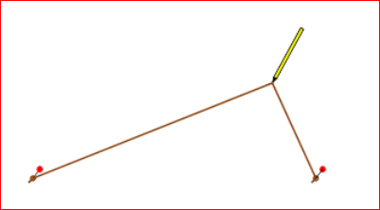







PEN







TAble

Support plate

Sheet of paper

Pins









































































































b)

 

c)







 







d)



 







For each of two elipses the device has to be used













































For the projectile on elipse from measurements :













For the projectile on elipse  from measurements:













e) Modeling one wire on each sector SA:





**C.**

a)































































a-A:







*Security elipse* .



22697,84 km;



Conturul elipsei de siguranță se trasează așa cum indică desenul din figura alăturată.









Pen











































b)

c)















































 





 



